PATIENT INFORMATION
Date:___________
Name:____________________________________
Address:___________________________________
_________________________________________
City State Zip
Sex: □ M □ F □ Other Age:_____ Birth Date:_______
□ Single □ Married □ Widowed □ Separated □ Divorced
Patient SS #:_______________________________
Occupation:________________________________
Employer:__________________________________
Spouse/Partner’s Name:_______________________
PHONE NUMBERS
(H): _____________ (W):____________ (C):_____________
E-mail: _______________________________________
Emergency Contact:__________________________
Relationship:___________ Phone: ______________
Primary Care Doctor:__________________________
Phone:____________________________________
Attorney (if a PI case):_________________________

PATIENT CONDITION
▪Reason for visit:_____________________________
▪What date did symptoms appear:________________
▪Is this condition due to an accident? □ yes □ no
If yes, what type: □ Auto □ Work □ Home □ Other
▪Have you had treatment for this condition: □ yes □ no
If yes, what type and from whom:_________________
_________________________________________
▪Have you had X-rays, MRI or CT for this: □ yes □ no
If yes, when and where:________________________
▪Is your condition getting worse: □ yes □ no □ not sure
▪Rate the severity of your pain on a scale of 1-10:_____
▪Type of pain:□ Sharp □ Dull □ Aching □ Throbbing □ Stiff
□ Shooting □ Burning □ Numbness □ Tingling □ Spasm
▪Frequency of Pain: □ Constant □ Comes and Goes
▪Does it interfere with your: □ work □ sleep □ dressing
□ recreation □ daily routine
▪Pain or difficulty with: □ sitting □ standing □ walking
□ rising from a chair □ bending □ lying down □ lifting
Please mark an X on the picture below where you are having pain, numbness or tingling:
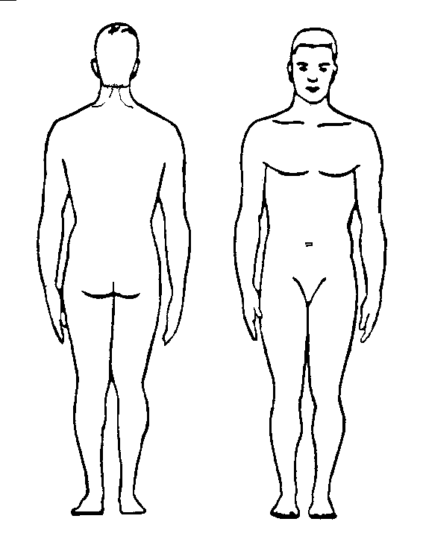
HEALTH HISTORY
Please indicate it you currently have or have had any of the following in the past:

AIDS/HIV □yes □no Herniated Disc □yes □no
AD/HD □yes □no Herpes □yes □no
Alcoholism □yes □no High Cholesterol □yes □no
Anemia □yes □no Hypertension □yes □no
Asthma □yes □no Joint Dislocation □yes □no
Cancer □yes □no Joint Replaced □yes □no
Concussion □yes □no Joint Injury □yes □no
Depression □yes □no Kidney Disease □yes □no
Drug Addiction □yes □no Liver Disease □yes □no
Eating Disorder □yes □no Lung Disease □yes □no
Ear Problems □yes □no Measles □yes □no
Eye Problems □yes □no Multiple Sclerosis □yes □no
Chicken Pox □yes □no Osteoporosis □yes □no
Diabetes □yes □no Osteoarthritis □yes □no
Epilepsy □yes □no Pacemaker □yes □no
Fractures □yes □no Parkinson’s □yes □no
Glaucoma □yes □no Prostate Problem □yes □no
Gout □yes □no Rheumatoid Arth. □yes□no
Headaches □yes □no Sleep Disorder □yes □no
Heart Disease □yes □no Stroke □yes □no
Heart Attack □yes □no Thyroid Problem □yes □no
Hepatitis □yes □no Tuberculosis □yes □no
Hernia □yes □no Venereal Disease □yes □no
Allergies □yes □no Other: ________________
________________________________________
Have you ever had injuries from a Fall, Sports, Exercise, Car Accident or at home? □ yes □ no
If yes, please explain:________________________
________________________________________

Have you ever had Surgery? □ yes □ no
If yes, please explain:________________________
________________________________________
Please List all Medications:____________________
________________________________________
________________________________________
Please List all Supplements/Vitamins:____________
________________________________________
________________________________________

HABITS
□ Smoking/Tobacco: How much per day?____________
□ Alcohol: How much per week?___________________
□ Coffee/Caffeine: How much per day?______________

PHYSICAL ACTIVITY/EXERCISE
Work Activity: □sitting □standing □light labor □heavy labor
Do you Exercise? □ yes □ no If yes, what type and how often?______________________________________
___________________________________________

